Software Engineering Project

Project name: Online Consulting Doctor

Course Name: Software Engineering

Team Name: Linux

**Members:**

1. Habib,MD. Tahsinur Rahman Id = 18-37837-2
2. Anjum, Nafisa Id = 18-38091-2
3. Sakib, Md. Sajid Al Id = 18-38085-2

**Online Consulting Doctor**

**Problem Analysis:**

Being hospitalized or getting treatment has always been a huge problem in our country as we have less hospital and less doctor as per we need. Sometimes we don't have the time to check door to door of every hospital to get appointment for a doctor or getting an ICU. In this such a pandemic situation where we need to stay at home for specially this consequence its quite impossible to meet a doctor physically. If somehow we can reduce this problems there will be a huge chance to save a life. Now a days, our country is going through with such a pandemic where getting treatment has become a huge problem. That's why we want to develop a system which can reduce such kind of problem for which we are suffering like getting appointment from a doctor or getting an ICU etc. Though we want to do something better for our patient but it will also be a good opportunity for us to grave the software market with a huge benefit. More than that, our main goal is to think about the patients. For all of these reason we want to do Online Doctor Consulting software project .

**Requirement Analysis:**

In this situation, many hospitals are closed, that’s why peoples are suffering day by day. We decided to solve this problem through online. People can use this software to contact with doctors immediately. This software also will be easily useable. In this software, doctors can register there profile and set how much fee he/she want. Patient can easily log in and request for the doctors and then the doctor will accept his/her request and send the time for visit.

**Function Requirements:**

Here are the all function of this software:

1) Simple log in process.

2) Making profile of doctors.

3) 3 categories for visit a doctor.

4) Immediate ICU.

5) Booking an ICU.

6) Free Doctors.

7) Online Payment

**Non – Functional Requirements:**

1. Availability
2. Performance
3. Efficiency
4. Integrity
5. Interoperability
6. Reliability
7. Robustness
8. Usability

All the functional and non function requirement has leveled with the system. We give prority for all of those requirments. It demonstrate the system development equally.

**Mind Map:**

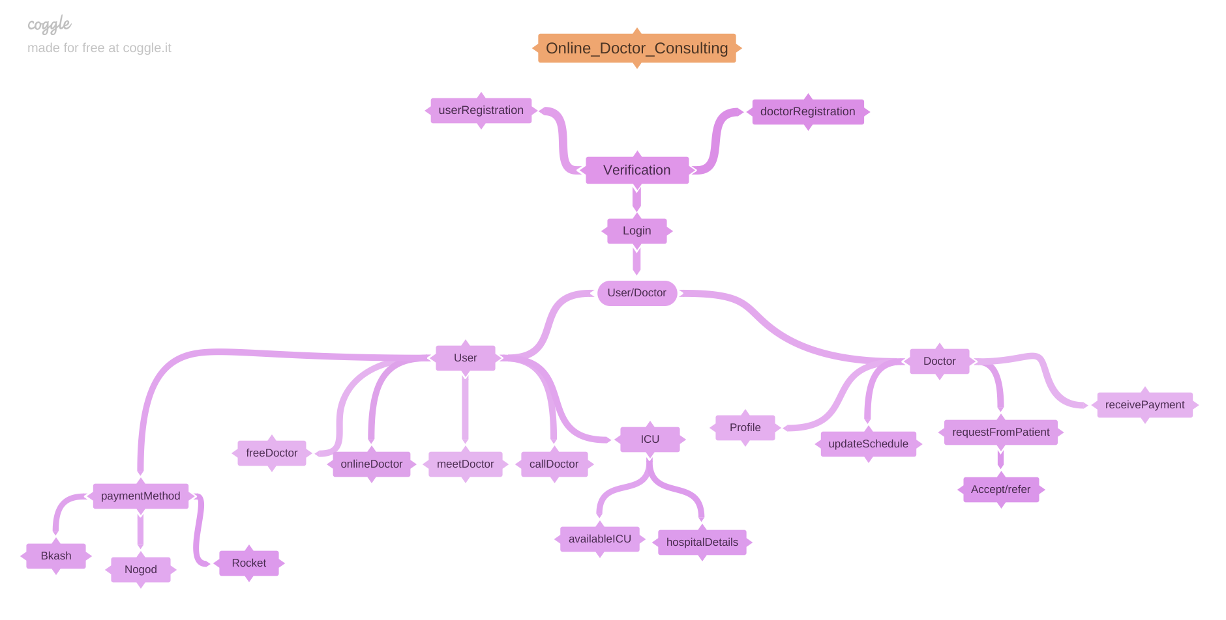

**Design Specification:**

Use case diagram:

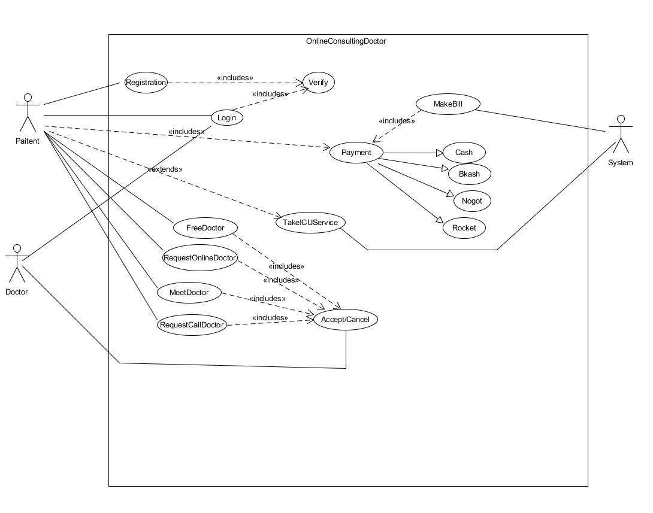

Activity Diagram:

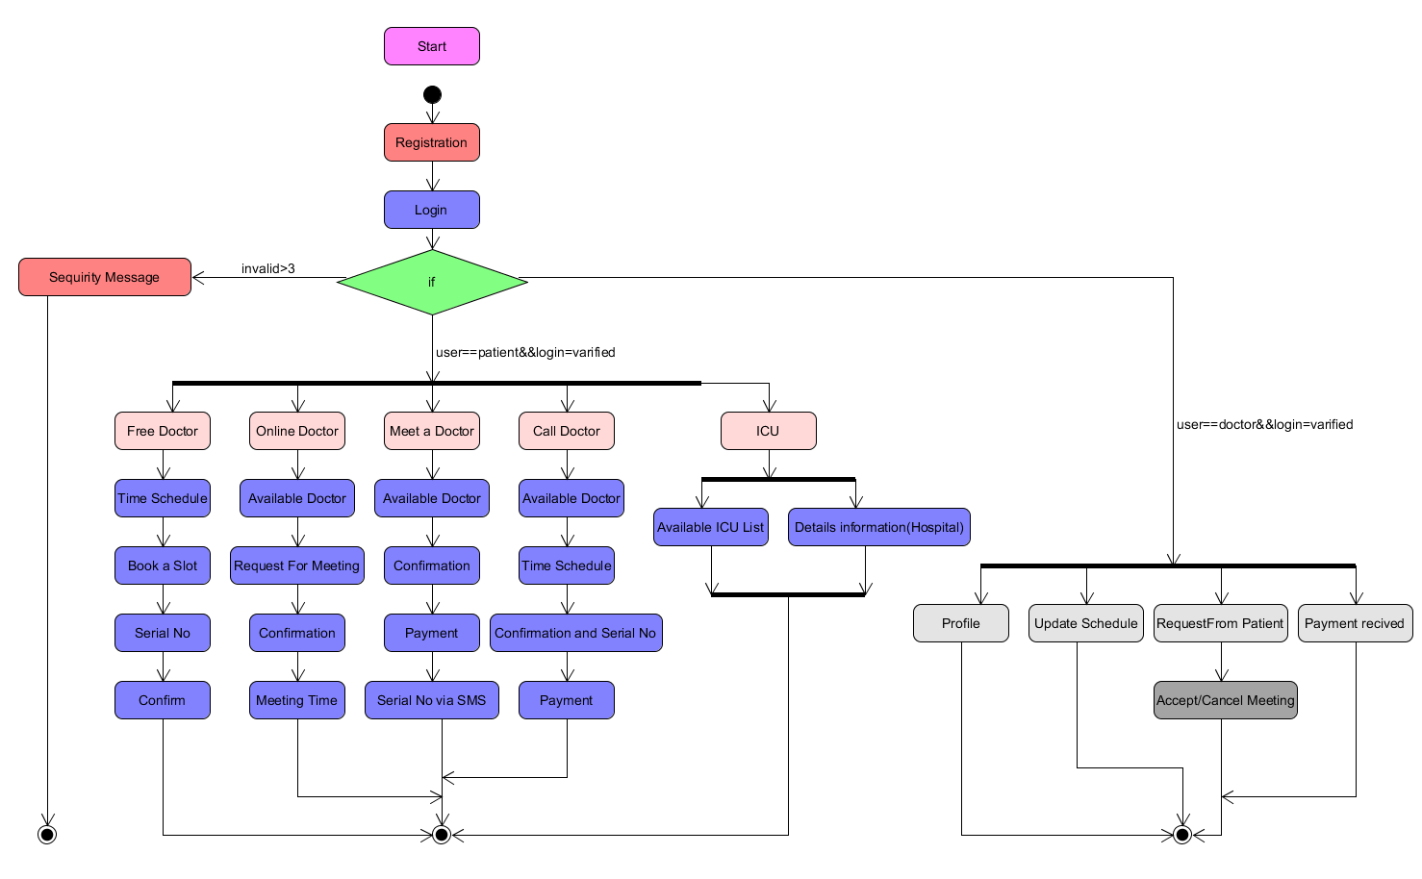

Sequence diagram:

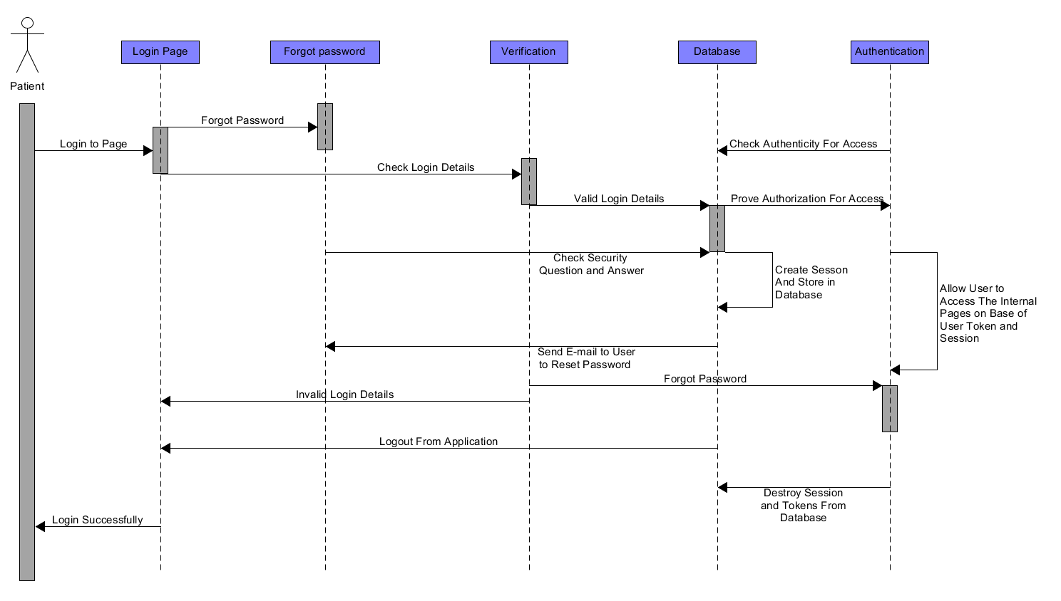

Fig-1

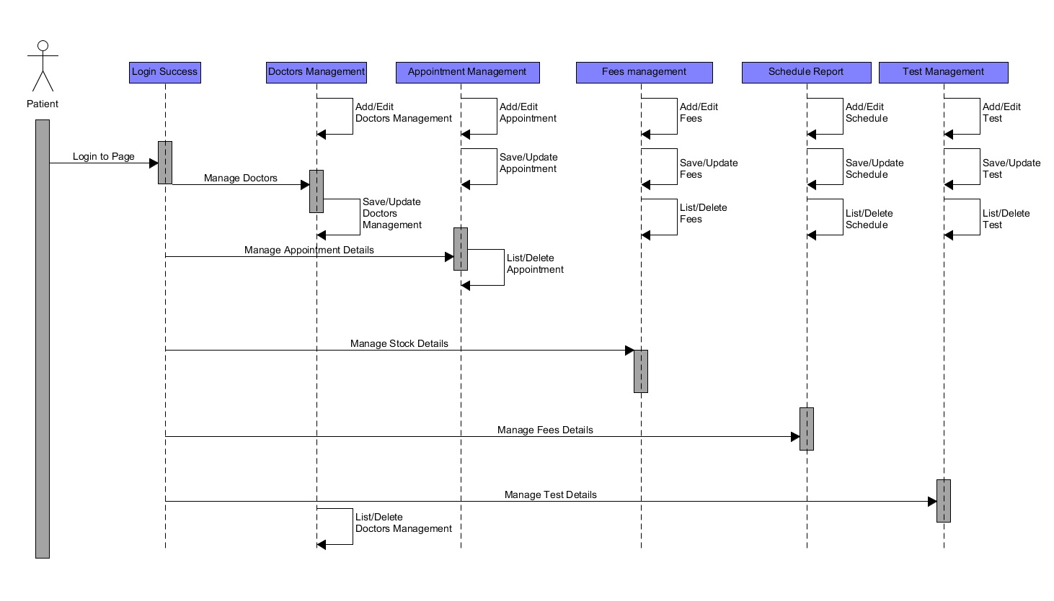

Fig-2

**Model Selection:**

The software development models are the various processes or methodologies that are being selected for the development of the project depending on the project's aims and goals. There are many development life cycle models that have been developed in order to achieve different required objectives. For our project we select the AGILE SOFTWARE DEVELOPMENT MODEL.

Agile is lightweight iterative model. In this model the time duration per scope is at best one month. In our project, we have some functionality which are characterized into specific parts for which the time duration (<=1month) is best for us. In software development the shorter time period is more useful because in lower time period a software development team develop a lower amount of functionalities than the bigger time period. And if we made any mistake during this time box we can easily solve our errors. One of the best practice in agile model has in every iteration after the work successful testing is necessary. Testing is the one of the best way to find out the errors or system bug. If we find out our bugs soon then it will be helpful to solve this small amount of bug. In future if system need any kind of change it is necessary to build proper documentation of the system which we will keep writing in each iteration. Agile development means automation and efficiency. Each member of the team is focused on the goal, the idea of the project is thin, each member knows the amount of effort it needs to put into the project and meet the demands. In teamwork, there is a need to have a look at the tasks each member performs, how tasks are categorized and what should be working strategy to be followed by each member. Software development requires tools to manage the project efficiently. This would help in understanding the project, categorizing the requirements of the project, prioritizing the tasks, assigning the tasks to the appropriate person in the team, following the project timeline efficiently. Every software is developed for specific design and specific people. So customer satisfaction is the major issues. Agile is the people base model rather than the paper base. So by using agile we can understand the customer feedback early because the “TimeBox” of every scope is at best one month so we can make small amount of functionalities and make a test and we understand either the functionalities are good or bad, if any change is required we can easily do it.

For all of those reason we selected agile is the best and suitable model for our Online Consulting Doctor project.

**Software Interfaces:**

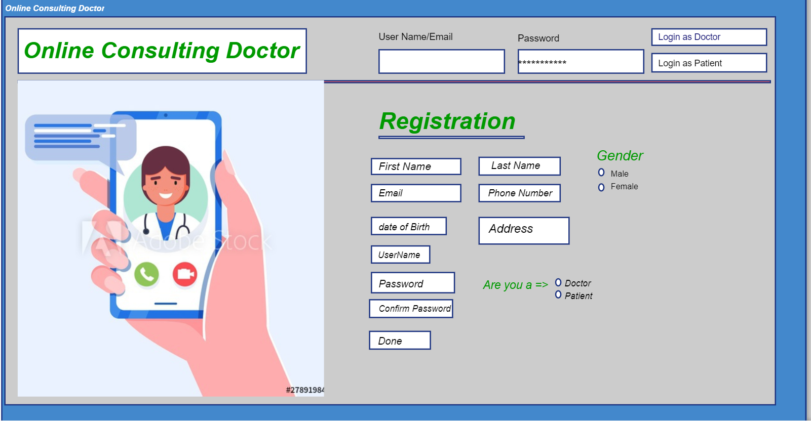

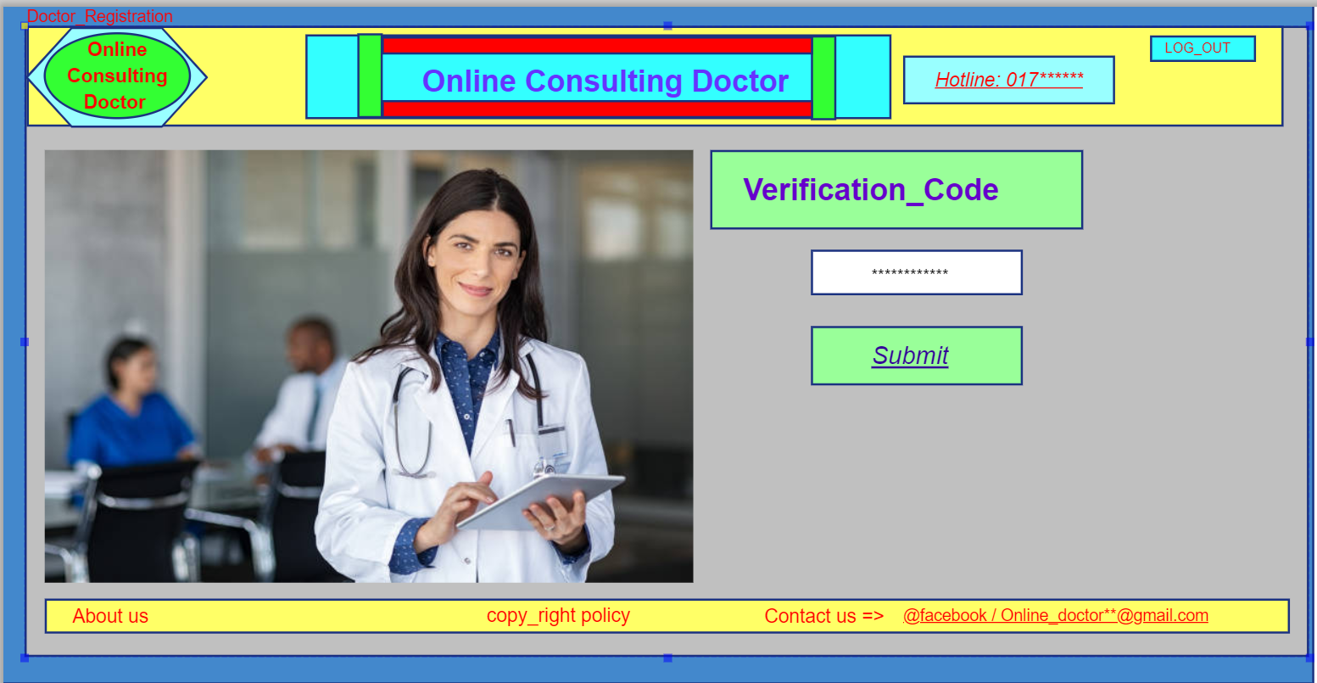

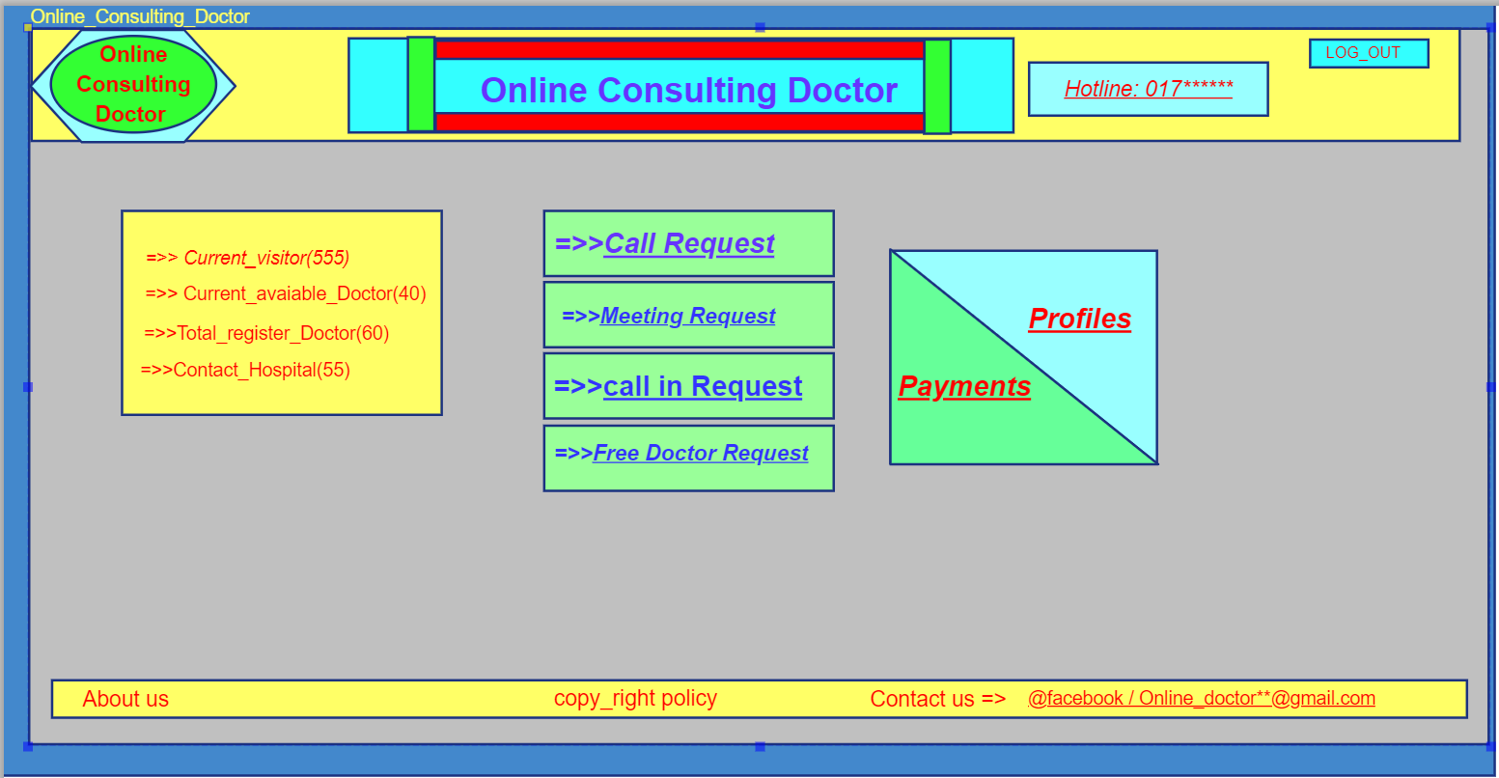

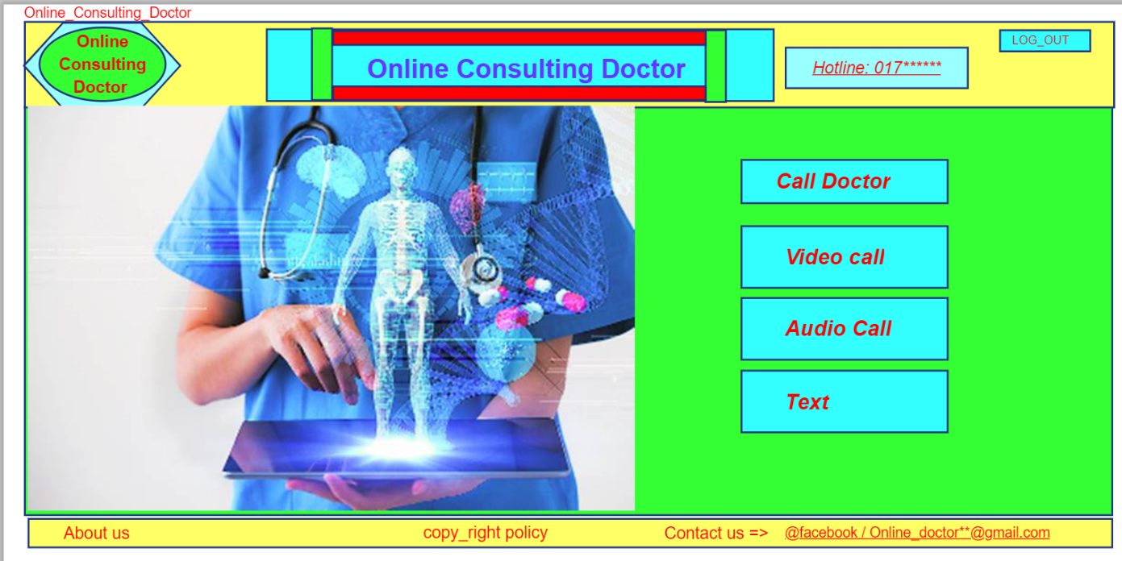

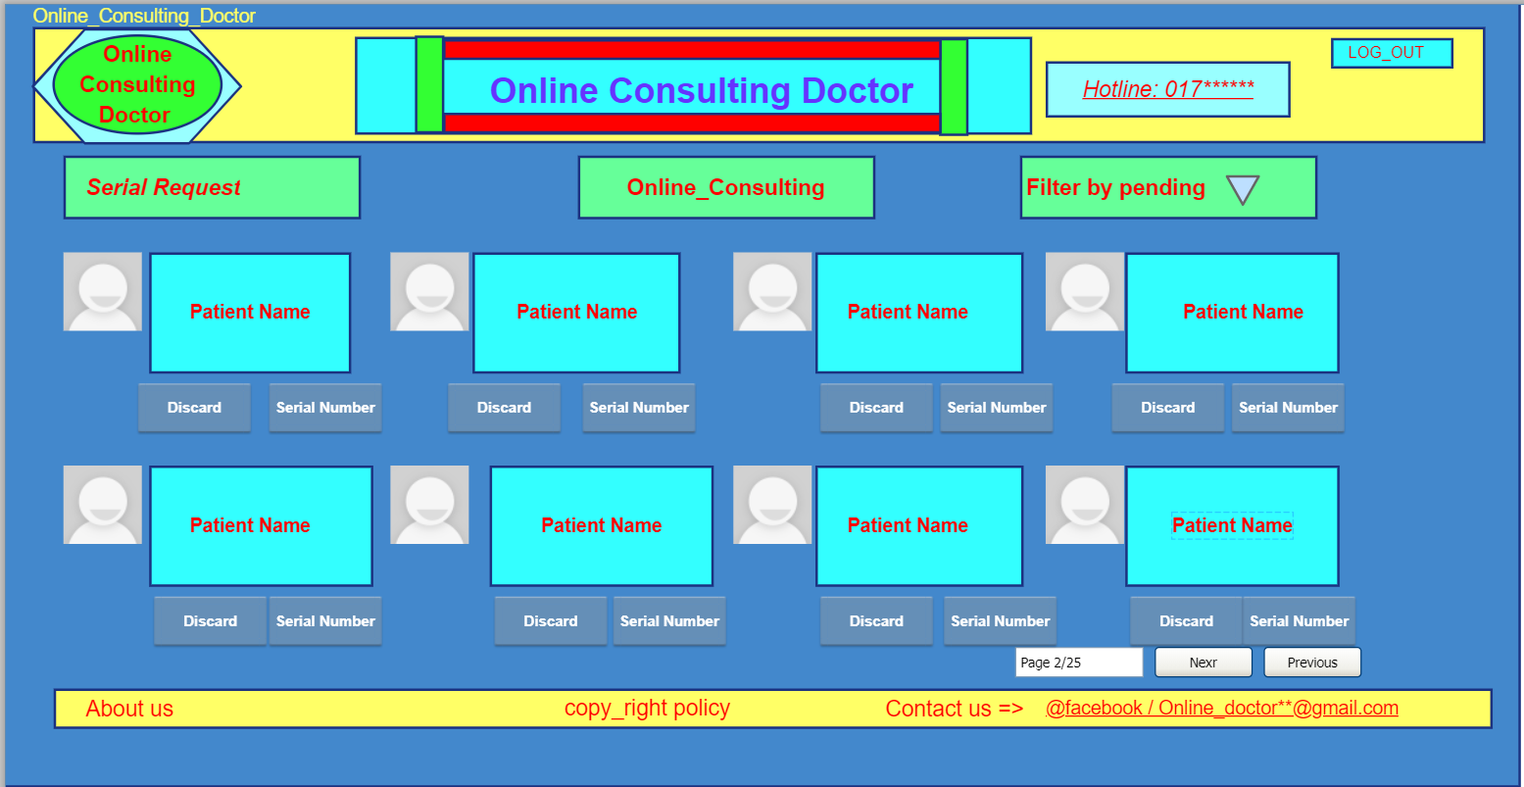

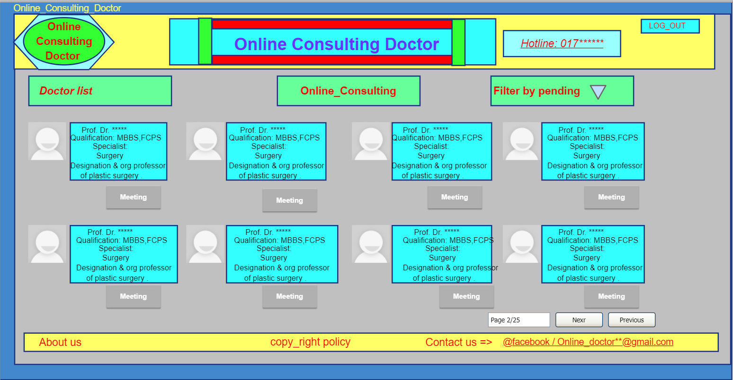

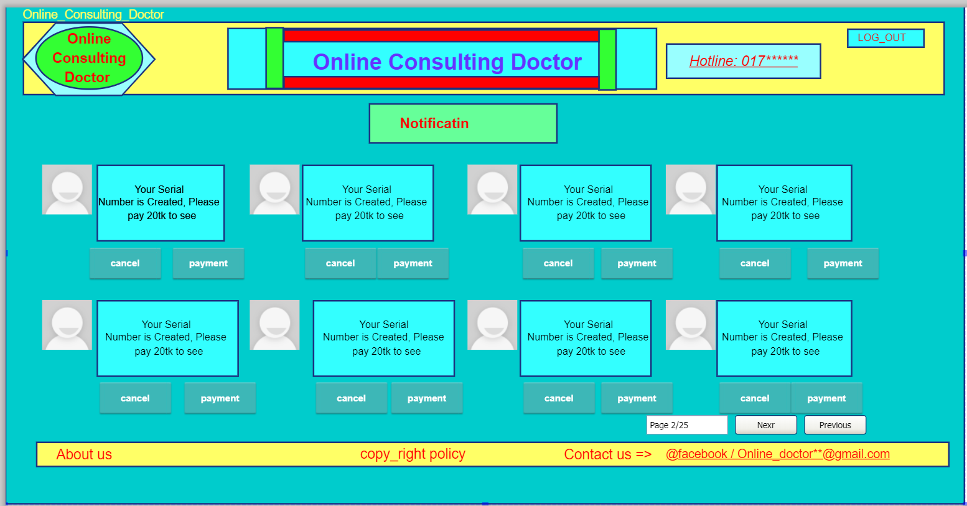

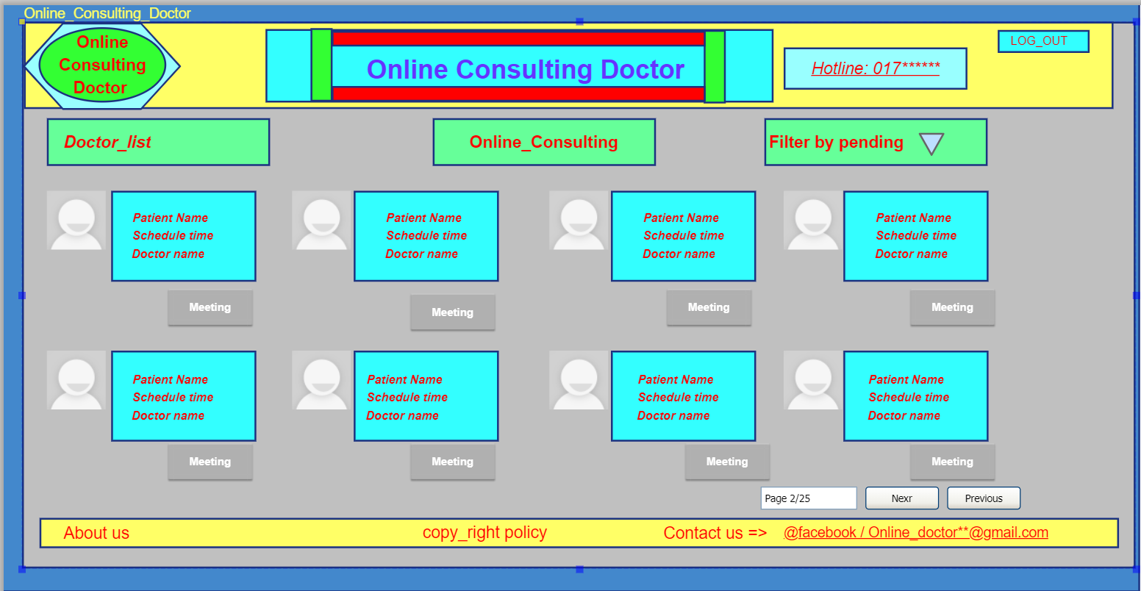

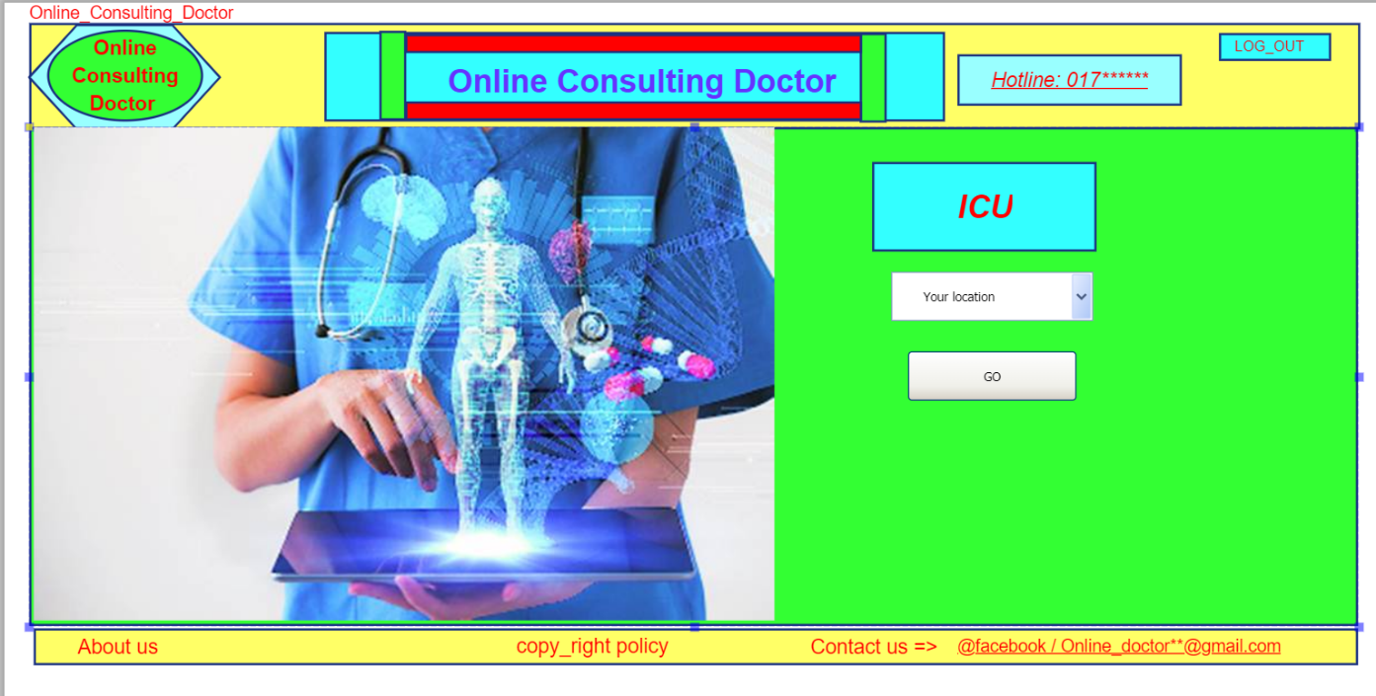

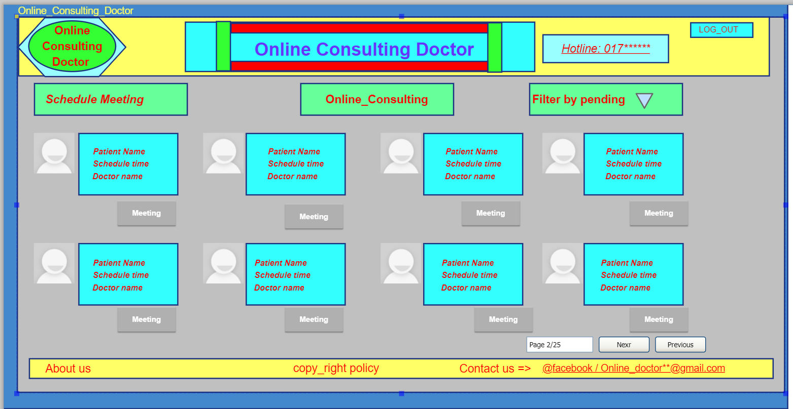

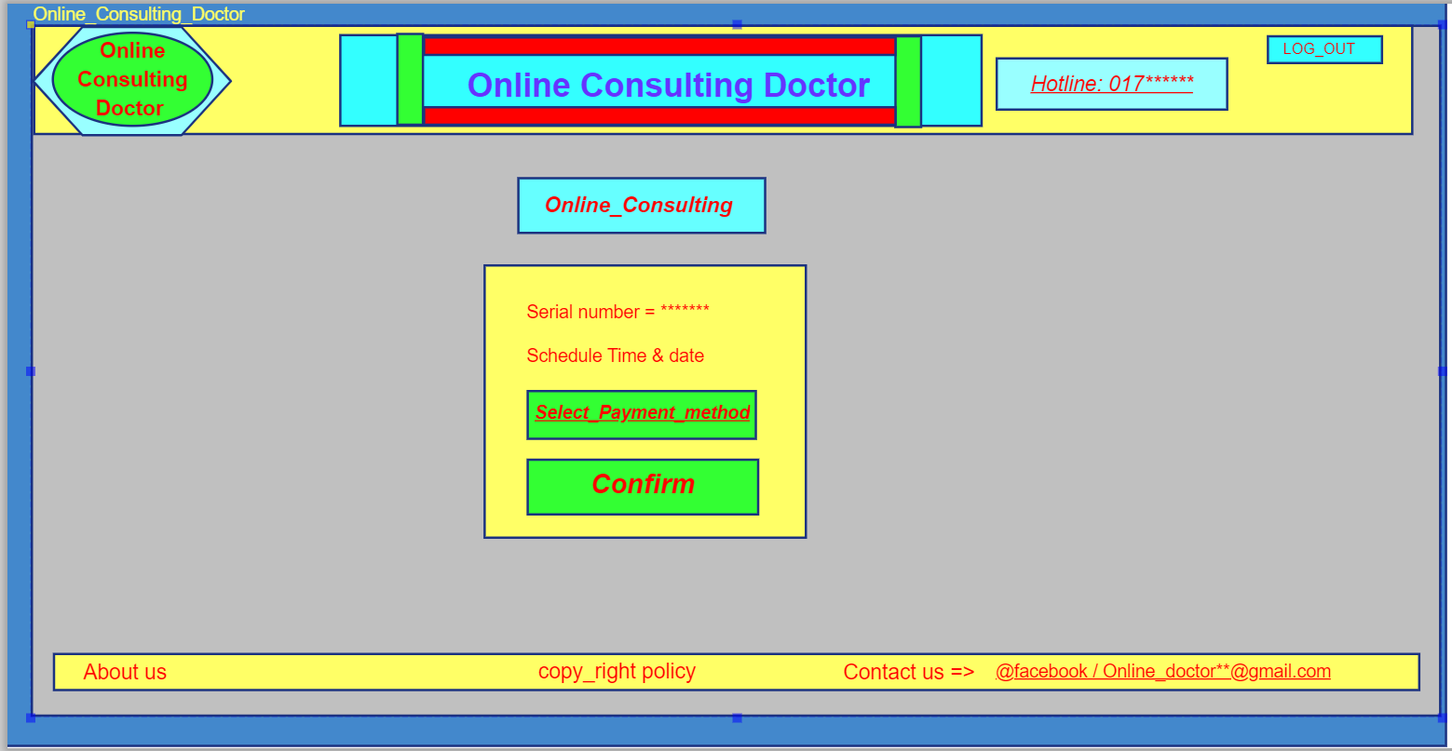

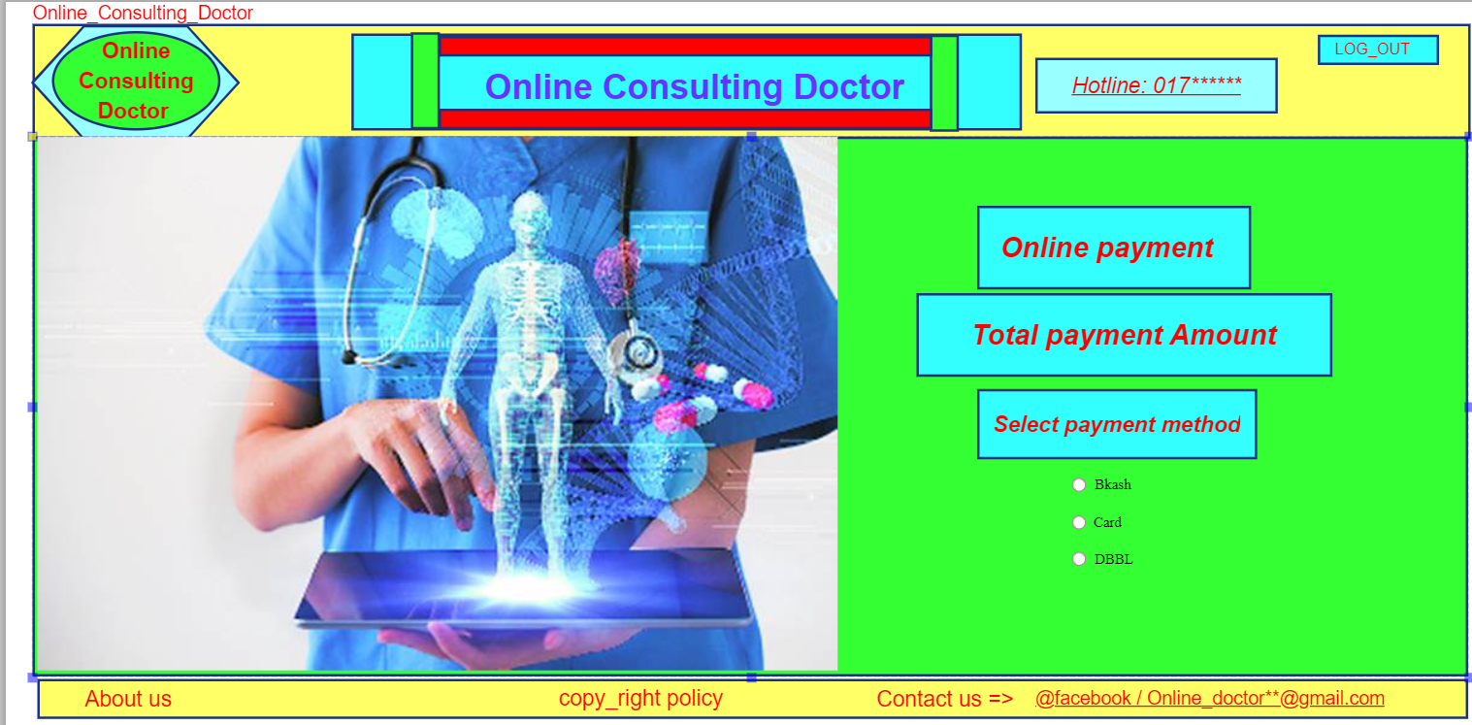

**TESTING**

**PROJECT TEST PLANNING:**

Making a test plan has multiple benefits. Prime reason for test planning is it ensures software quality. The question is what is “What is Software Quality?” evokes many different answers. Quality is a complex concept—it means different things to different people, and it is highly context dependent. Software Quality (as IEEE Std 610): The degree to which a component, system or process meets specified requirements and/or user/customer needs and expectations [4]. Other benefits can be:

● Help people outside the test team such as developers, business managers, customers understand the details of testing.

● Test plan guides our thinking. It is like a rule book, which needs to be followed.

● important aspects like test estimation, test scope, Test strategy are documented in test plan. So it can be reviewed by Management Team and re-used for other projects.

As per IEEE 829 test plan can be created by following this rules:

● Analyze the product

● Design the Test Strategy

● Define the Test Objectives

● Define Test Criteria

● Resource Planning

● Plan Test Environment

● Schedule & Estimation

● Determine Test Deliverables

Performing various techniques for testing using the testing tool: unit testing, integration testing, Blackbox testing, Whitebox testing, etc.

Procedure:

1. A particular system was selected. Desktop in this case. (Web/Desktop/Mobile/Device)

2. Various modules of the system were identified so that they can be tested stand alone.

3. Test cases were prepared of testing the selected elements of your identified software.

4. The test was performed according to the generated test case and a bug report was produced which will helpful for the system developer to modify the system for improve system’s quality.

**Test Cases**

**Test cases: Registration**

|  |  |  |  |  |
| --- | --- | --- | --- | --- |
| Project Name: Online Consulting Doctor | | | Test Designed by: Md. Tahsinur Rahman Habib | |
| Test Case ID: FR_1 | | | Test Designed date: 18/12/20 | |
| Test Priority (Low, Medium, High): High | | | Test Executed by: | |
| Module Name: Registration Session | | | Test Execution date: | |
| Test Title: Validation of personal information with username and password and registration. | | | | |
| Description: Registration of Patient contains personal information and username-password combo which is appended in the database after successful validation (Instant Test Procedure). Registration of Doctor contains personal information with attachment and username-password combo which is appended in the database after successful validation (Long Test Procedure). | | | | |
| Preconditions: N/A | | | | |
| Test Steps | Test Data | Expected Results | Actual Results | Status  (Pass/Fail) |
| 1. Go to the website  For Patient:  2. Enter required information and username and password  For Doctor:  2. Enter required information, attach file and username and password  3. Click submit | For Patient:  Username:  alice_143  Password:  Security101princess  Verification code:  675754  For Doctor:  Username:  bob_007  Password:  master_surgeon  Verification code:  132435 | For Patient:  User should be able to register.  For Doctor:  User should be able to register if all information seems legit. |  |  |
| Post condition: User information is validated and appended in the database. | | | | |

**Test cases: Login**

|  |  |  |  |  |
| --- | --- | --- | --- | --- |
| Project Name: Online Consulting Doctor | | | Test Designed by: Md. Tahsinur Rahman Habib | |
| Test Case ID: FR_2 | | | Test Designed date: 18/12/20 | |
| Test Priority (Low, Medium, High): High | | | Test Executed by: | |
| Module Name: Login Session | | | Test Execution date: | |
| Test Title: Verify login with valid username and password. | | | | |
| Description: Successful login will pass login credentials through database. | | | | |
| Preconditions: User must have valid username and password. | | | | |
| Test Steps | Test Data | Expected Results | Actual Results | Status  (Pass/Fail) |
| 1. Go to the website  For Patient:  2. Enter username and password  For Doctor:  2. Enter username and password  3. Click submit | For Patient:  Username:  alice_143  Password:  Security101princess  For Doctor:  Username:  bob_007  Password:  master_surgeon | For Patient:  User should be able to login into the web.  For Doctor:  User should be able to login into the web. |  |  |
| Post condition: User is validated with database and successfully login to account. The account session details are appended in the database. | | | | |

**Test cases: Online Doctor**

|  |  |  |  |  |
| --- | --- | --- | --- | --- |
| Project Name: Online Consulting Doctor | | | Test Designed by: Md. Tahsinur Rahman Habib | |
| Test Case ID: FR_3 | | | Test Designed date: 19/12/20 | |
| Test Priority (Low, Medium, High): High | | | Test Executed by: | |
| Module Name: Online Doctor | | | Test Execution date: | |
| Test Title: To check Online doctor module is work perfectly. | | | | |
| Description: Online doctor module is the platform where a user can meet with a doctor through online and patients can make e request for his/her choose doctor. | | | | |
| Preconditions: Should be valid users. | | | | |
| Test Steps | Test Data | Expected Results | Actual Results | Status  (Pass/Fail) |
| 1. All types of Searching should be work perfectly within 15 sec.  For Patient:  2. Payment validation.  3. Notify Patients about appointment information. | 1.  Dr. Bruce  Dr. Robert  Location: Dhaka  Category : Burn unit  2.Code:832683  Seral no;20 | 1. Users should be done all types of searching without any major buffering within 10 sec.  2. We have to confirm that there should not be any kind of security problem and validate the payment system.  3. After confirmation system will notify the patients about appointment time and date. |  |  |
| Post condition: Database should be update properly and insert all data into the database. | | | | |

**Test cases: Meet a doctor**

|  |  |  |  |  |
| --- | --- | --- | --- | --- |
| Project Name: Online Consulting Doctor | | | Test Designed by: Md. Tahsinur Rahman Habib | |
| Test Case ID: FR_4 | | | Test Designed date: 19/12/20 | |
| Test Priority (Low, Medium, High): High | | | Test Executed by: | |
| Module Name: Meet a doctor | | | Test Execution date: | |
| Test Title: To check the meet a doctor module work perfectly | | | | |
| Description: Make sure the meet a doctor module is working perfectly by checking serial request and confirmation as well as discard. | | | | |
| Preconditions: Must have valid users. | | | | |
| Test Steps | Test Data | Expected Results | Actual Results | Status  (Pass/Fail) |
| 1. All types of Searching should be work perfectly within 15 sec.  For Patient:  2. Payment validation.  For doctor:  3. Notify doctor about appointment information. | 1.  Dr. Clerk  Location :Dhaka  Category : Burn unit  2.Code:832683  Seral no;20 | 1. Users should be done all types of searching without any major buffering within 10 sec.  2. We have to confirm that there should not be any kind of security problem and validate the payment system.  3. System should be notify the doctor about the appointment request. |  |  |
| Post condition: Confirmation should be update in the proper time. | | | | |

**Test cases: Call in a doctor**

|  |  |  |  |  |
| --- | --- | --- | --- | --- |
| Project Name: Online Consulting Doctor | | | Test Designed by: Md. Tahsinur Rahman Habib | |
| Test Case ID: FR_5 | | | Test Designed date: 18/12/20 | |
| Test Priority (Low, Medium, High): High | | | Test Executed by: | |
| Module Name: Call in a Doctor | | | Test Execution date: | |
| Test Title: Searching doctor and send a request to doctor | | | | |
| Description: Call in a doctor, For patient: will able to search doctors with different categories and send request to the doctors by doing a successful payment. For doctor: doctors can accept or decline the requests. Both of the user can give feedback after the meeting to the system. | | | | |
| Preconditions: Log in to the system with valid username and password. | | | | |
| Test Steps | Test Data | Expected Results | Actual Results | Status  (Pass/Fail) |
| For Patient:  1. All types of Searching should be work perfectly within 15 sec.  2. User can send request to their preferred doctor.  3. Payment validation  4. Feedback submission  For Doctor:  1. Doctor can accept or decline requests.  2. Feedback submission | For Patient:  Doctor’s Category:  Bone specialist  Location:  Dhaka  Payment validity:  Transaction code: 157934  Serial number: 37 | For Patient:  1. User should be able to send request for a doctor.  2. User should be able to make payment and get a serial number  For Doctor:  User should be able Accept or decline the request.  For Patient and doctor:  User should be able to give feedback about their doctor/patient |  |  |
| Post condition: User information is validated and appended in the database. | | | | |

**Test cases: ICU**

|  |  |  |  |  |
| --- | --- | --- | --- | --- |
| Project Name: Online Consulting Doctor | | | Test Designed by: Md. Tahsinur Rahman Habib | |
| Test Case ID: FR_6 | | | Test Designed date: 19/12/20 | |
| Test Priority (Low, Medium, High): High | | | Test Executed by: | |
| Module Name: Immediate ICU | | | Test Execution date: | |
| Test Title: Verify searching an ICU | | | | |
| Description: Successful search for available ICU | | | | |
| Preconditions: Must have a username and password | | | | |
| Test Steps | Test Data | Expected Results | Actual Results | Status  (Pass/Fail) |
| For Patient:  All types of Searching should be work perfectly within 15 sec.  For Hospitals:  All types of Searching should be work perfectly within 15 sec. | For Patient:  Searching:  Dhaka medical Hospital.  Location:  Dhaka  Update ICU beds:  Available:3 ,used:9 | For Patient:  User should be able to find the expected Hospital  User should be able to update the hospitals ICU bed’s information |  |  |
| Post condition: User is validated with database and successfully login to account. | | | | |

**Test cases: Free Doctor**

|  |  |  |  |  |
| --- | --- | --- | --- | --- |
| Project Name: Online Consulting Doctor | | | Test Designed by: Md. Tahsinur Rahman Habib | |
| Test Case ID: FR_7 | | | Test Designed date: 19/12/20 | |
| Test Priority (Low, Medium, High): Medium | | | Test Executed by: | |
| Module Name: Free Doctor | | | Test Execution date: | |
| Test Title: To check free doctor module is work perfectly. | | | | |
| Description: Free doctor, for patient: will able to search doctors with different categories and send request to the doctors by doing a successful payment. For doctor: doctors will check his/her free schedule and then he/she can accept or decline the requests. Both of the user can give feedback after the meeting to the system. | | | | |
| Preconditions: Should be valid users. | | | | |
| Test Steps | Test Data | Expected Results | Actual Results | Status  (Pass/Fail) |
| 1. Updated doctor  Schedule with limited addition will provided with their respective free consulting hours  For Patient:  2. Payment validation.  3. Notify Patients about appointment information. | 1.Dr. Rouf  Bone Specialist  Consulting hour : 3-5 pm  Location: Dhaka  2.Code:832685  Seral no :20 | 1. Users can choose their respective doctor schedule.  2. We have to confirm that there should not be any kind of security problem and validate the payment system.  3. After confirmation system will notify the patients about appointment time and date. |  |  |
| Post condition: Database should be update properly and insert all data into the database. | | | | |

**Test cases: Payment**

|  |  |  |  |  |
| --- | --- | --- | --- | --- |
| Project Name: Online Consulting Doctor | | | Test Designed by: Anjum, Nafisa | |
| Test Case ID: FR_8 | | | Test Designed date: 19/12/20 | |
| Test Priority (Low, Medium, High): High | | | Test Executed by: | |
| Module Name :Successful Payment | | | Test Execution date: | |
| Test Title : Verify security purpose to transfer money | | | | |
| Description: Verification of user identity with authentic source and complete patient’s doctor fees. | | | | |
| Preconditions: Must have valid users. | | | | |
| Test Steps | Test Data | Expected Results | Actual Results | Status  (Pass/Fail) |
| 1. Necessary available balance for doctor payment.  For Patient:  2. Payment confirmation  For Patient:  3. Payment validation.  For doctor:  4. Notify doctor about appointment information. | 1.Mr. Hassan  Account no : 7644844  Balance : 856789 $  2. Mr. Hassan  Doctor fees :700tk  3.Code:832683  Seral no;20 | 1. Users should have available balance to pay doctor fees.  2. Users have to pay doctor fees and confirm payment action.  3. We have to confirm that there should not be any kind of security problem and validate the payment system.  4. System should be notify the doctor about the appointment request. |  |  |
| Post condition: Confirmation should be update in the proper time. | | | | |

**NFR Test Cases**

**Test cases: Availability**

|  |  |  |  |  |
| --- | --- | --- | --- | --- |
| Project Name: Online Consulting Doctor | | | Test Designed by: Anjum, Nafisa | |
| Test Case ID: NFR_1 | | | Test Designed date: 26/12/20 | |
| Test Priority (Low, Medium, High): N/A | | | Test Executed by: | |
| Module Name: Availability | | | Test Execution date: | |
| Test Title: Response time of the system. | | | | |
| Description: At different time system will get different number of hits. According to that an available percentage has been set varying weekdays and weekends. It also includes time shift. | | | | |
| Preconditions: N/A | | | | |
| Test Steps | Test Data | Expected Results | Actual Results | Status  (Pass/Fail) |
| Go the website at different time on different days. | N/A | According to condition, system should response properly. |  |  |
| Post condition: N/A | | | | |

**Test cases: Performance**

|  |  |  |  |  |
| --- | --- | --- | --- | --- |
| Project Name: Online Consulting Doctor | | | Test Designed by: Anjum, Nafisa | |
| Test Case ID: NFR_2 | | | Test Designed date: 20/12/20 | |
| Test Priority (Low, Medium, High): N/A | | | Test Executed by: | |
| Module Name: Performance | | | Test Execution date: | |
| Test Title: Performance of the system based on some activities of the system. | | | | |
| Description: At different action, system should response properly according to expected time. This includes the parts like authentication time, download time, searching time, and validation time. | | | | |
| Preconditions: N/A | | | | |
| Test Steps | Test Data | Expected Results | Actual Results | Status  (Pass/Fail) |
| Measuring time on the action of authentication, download, search, validation. | N/A | According to expected time, system should response properly. |  |  |
| Post condition: N/A | | | | |

**Test cases: Efficiency**

|  |  |  |  |  |
| --- | --- | --- | --- | --- |
| Project Name: Online Consulting Doctor | | | Test Designed by: Anjum, Nafisa | |
| Test Case ID: NFR_3 | | | Test Designed date: 20/12/20 | |
| Test Priority (Low, Medium, High): N/A | | | Test Executed by: | |
| Module Name: Efficiency | | | Test Execution date: | |
| Test Title: Increasing system efficiency and giving user a smooth experience with the help of a methodology. | | | | |
| Description: According to user’s internet speed, system will automatically reduce/increase images quality to give user a smooth experience. | | | | |
| Preconditions: N/A | | | | |
| Test Steps | Test Data | Expected Results | Actual Results | Status  (Pass/Fail) |
| Reduce/Increase the quality of system images. | N/A | According to user internet speed, system should response at its best. |  |  |
| Post condition: N/A | | | | |

**Test cases: Reusability**

|  |  |  |  |  |
| --- | --- | --- | --- | --- |
| Project Name: Online Consulting Doctor | | | Test Designed by: Sakib, Md. Sajid Al | |
| Test Case ID: NFR_4 | | | Test Designed date: 21/12/20 | |
| Test Priority (Low, Medium, High): N/A | | | Test Executed by: | |
| Module Name: Reusability | | | Test Execution date: | |
| Test Title: | | | | |
| Description: Many pages of the system contains search function. One search function code can be used in others module too. This reusability analogy can also be implemented in payment module. | | | | |
| Preconditions: N/A | | | | |
| Test Steps | Test Data | Expected Results | Actual Results | Status  (Pass/Fail) |
| Use of one code in many module. | N/A | According to the analogy of reusability, the system should response properly. |  |  |
| Post condition: N/A | | | | |

**Test cases:**  **Integrity**

|  |  |  |  |  |
| --- | --- | --- | --- | --- |
| Project Name: Online Consulting Doctor | | | Test Designed by: Sakib, Md. Sajid Al | |
| Test Case ID: NFR_5 | | | Test Designed date: 21/12/20 | |
| Test Priority (Low, Medium, High): N\A | | | Test Executed by: | |
| Module Name**:**  Integrity | | | Test Execution date: | |
| Test Title: To ensure the security of the system as well as the users. | | | | |
| Description: For security purpose system have to ensure the all kinds of security of the users, | | | | |
| Preconditions :N\A. | | | | |
| Test Steps | Test Data | Expected Results | Actual Results | Status  (Pass/Fail) |
| 1. System will able to prevent unauthorized access.  2. Only permitted privileges will be able to access user transaction histories.  3. Payment transactions procedure will be handled in special security. |  | 1. Have to ensure system will have to able to prevent all kinds of unauthorized access.  2. We have to confirm that there should be only admin or administrative team will see the transaction histories.  3. System should be give more security about payment and make sure that all kind of payment should be done without any kind of unsecure issues. |  |  |
| Post condition: N\A | | | | |

**Test cases:**  **Interoperability**

|  |  |  |  |  |
| --- | --- | --- | --- | --- |
| Project Name: Online Consulting Doctor | | | Test Designed by: Sakib, Md. Sajid Al | |
| Test Case ID: NFR_6 | | | Test Designed date: 21/12/20 | |
| Test Priority (Low, Medium, High): N\A | | | Test Executed by: | |
| Module Name**:**  N\A | | | Test Execution date: | |
| Test Title: To ensure the all kind of other build in system’s use of our system. | | | | |
| Description: for some purpose we used another system’s module to our project. | | | | |
| Preconditions :N\A. | | | | |
| Test Steps | Test Data | Expected Results | Actual Results | Status  (Pass/Fail) |
| 1. ICU information from every hospital will be updated in the system database.  2. Symmetric communication between system and payment methods will be establish when a transaction is occurred. |  | 1. Avaialable ICU information provide from hospital database and make sure it’s work perfectly.  2. System use the different payment method that are made by that companies.so we have to ensure the proper work of it. |  |  |
| Post condition: Database should be update properly and insert all data into the database. | | | | |

**Test cases: Reliability**

|  |  |  |  |  |
| --- | --- | --- | --- | --- |
| Project Name: Online Consulting Doctor | | | Test Designed by: Sakib, Md. Sajid Al | |
| Test Case ID: NFR_7 | | | Test Designed date: 26/12/20 | |
| Test Priority (Low, Medium, High): N\A | | | Test Executed by: | |
| Module Name**:**  N\A | | | Test Execution date: | |
| Test Title: To ensure the system availability. | | | | |
| Description: Make sure how much time system will available with the total amount of time. | | | | |
| Preconditions : N\A. | | | | |
| Test Steps | Test Data | Expected Results | Actual Results | Status  (Pass/Fail) |
| 1. System will response more than or equal 99 times within 100 times. |  | 1. Make sure that system will available more than 99 times within 100 times. |  |  |
| Post condition: N\A | | | | |

**Test cases: Testability**

|  |  |  |  |  |
| --- | --- | --- | --- | --- |
| Project Name: Online Consulting Doctor | | | Test Designed by: Md. Tahsinur Rahman Habib | |
| Test Case ID: NFR_8 | | | Test Designed date: 20/12/20 | |
| Test Priority (Low, Medium, High): N\A | | | Test Executed by: | |
| Module Name**:**  N\A | | | Test Execution date: | |
| Test Title: To ensure test execution Cyclomatic complexity every module does not exceed 15. | | | | |
| Description: when we test some facture we have to ensure that Cyclomatic complexity every module does not exceed 15. | | | | |
| Preconditions :N\A. | | | | |
| Test Steps | Test Data | Expected Results | Actual Results | Status  (Pass/Fail) |
| 1. Only registration, login, search, payment modules has test data and according to Cyclomatic complexity every module does not exceed 15 which is a good limit to do performance. |  | 1. We have to ensure for test purpose as if Cyclomatic complexity every module does not exceed 15. |  |  |
| Post condition: N\A | | | | |

**Test cases: Robustness**

|  |  |  |  |  |
| --- | --- | --- | --- | --- |
| Project Name: Online Consulting Doctor | | | Test Designed by: Md. Tahsinur Rahman Habib | |
| Test Case ID: FR_9 | | | Test Designed date: 25/12/20 | |
| Test Priority (Low, Medium, High): N\A | | | Test Executed by: | |
| Module Name: Robustness | | | Test Execution date: | |
| Test Title: Auto save data for further use. | | | | |
| Description: All the information and activities will be auto save to prevent fail tolerance of the system. | | | | |
| Preconditions: N\A | | | | |
| Test Steps | Test Data | Expected Results | Actual Results | Status  (Pass/Fail) |
| 1. Saving information for further reuse |  | 1..filling up form or taking appointment for a doctor will be reserved in the database for further reuse |  |  |
| Post condition: N\A | | | | |

**Test cases: Usability**

|  |  |  |  |  |
| --- | --- | --- | --- | --- |
| Project Name: Online Consulting Doctor | | | Test Designed by : Habib, Md. Tahsinur Rahman | |
| Test Case ID: FR_10 | | | Test Designed date: 24/12/20 | |
| Test Priority (Low, Medium, High): N\A | | | Test Executed by: | |
| Module Name: Usability | | | Test Execution date: | |
| Test Title: To check user friendliness of the website | | | | |
| Description: How friendly users can use our website without having any difficulties | | | | |
| Preconditions: N\A | | | | |
| Test Steps | Test Data | Expected Results | Actual Results | Status  (Pass/Fail) |
| 1. System contains a simple UI because for this kind of system information and actions are more important.  2. A trained user shall be able to complete a web page within 5-6 minutes.  3. A fresh user may take to complete a web page within 10-15 minutes. |  | 1.Users can easily perform actions which are related to the website  2. Users who used this website before can easily interact with the actions.  3. New user needs a little bit lengthy time to cop up with the website. |  |  |
| Post condition: N\A. | | | | |

**Test cases: Maintainability**

|  |  |  |  |  |
| --- | --- | --- | --- | --- |
| Project Name: Online Consulting Doctor | | | Test Designed by: Habib, Md. Tahsinur Rahman | |
| Test Case ID: FR_11 | | | Test Designed date:26/12/20 | |
| Test Priority (Low, Medium, High): N\A | | | Test Executed by: | |
| Module Name: Maintainability | | | Test Execution date: | |
| Test Title: how easily our website can be modified | | | | |
| Description: Maintainability depends on how easily website can be understood, changed, tested and correct a defect in our website. | | | | |
| Preconditions: N\A | | | | |
| Test Steps | Test Data | Expected Results | Actual Results | Status  (Pass/Fail) |
| 1. System contains light-weights UI and functions which gives a maintenance programmer to modify easily. |  | 1.System can easily modified, understood, changed and tested |  |  |
| Post condition: N\A | | | | |

**WBS and Effort Estimation**

**WORK BREAKDOWN STRUCTURE:**

**Objective:** Perform project management activities: effort estimation, WBS, activity planning, resource allocation.

**Tools/ Apparatus:** Microsoft project.

**Procedure:**

1. Identify all the micro tasks related to project management and categorize them within the WBS structure

2. Perform detailed effort estimation correspond with the WBS and schedule 3. Draw a network diagram of the identified tasks from WBS based on the precedence of each tasks you’ve identified.

**STRUCTURE:**

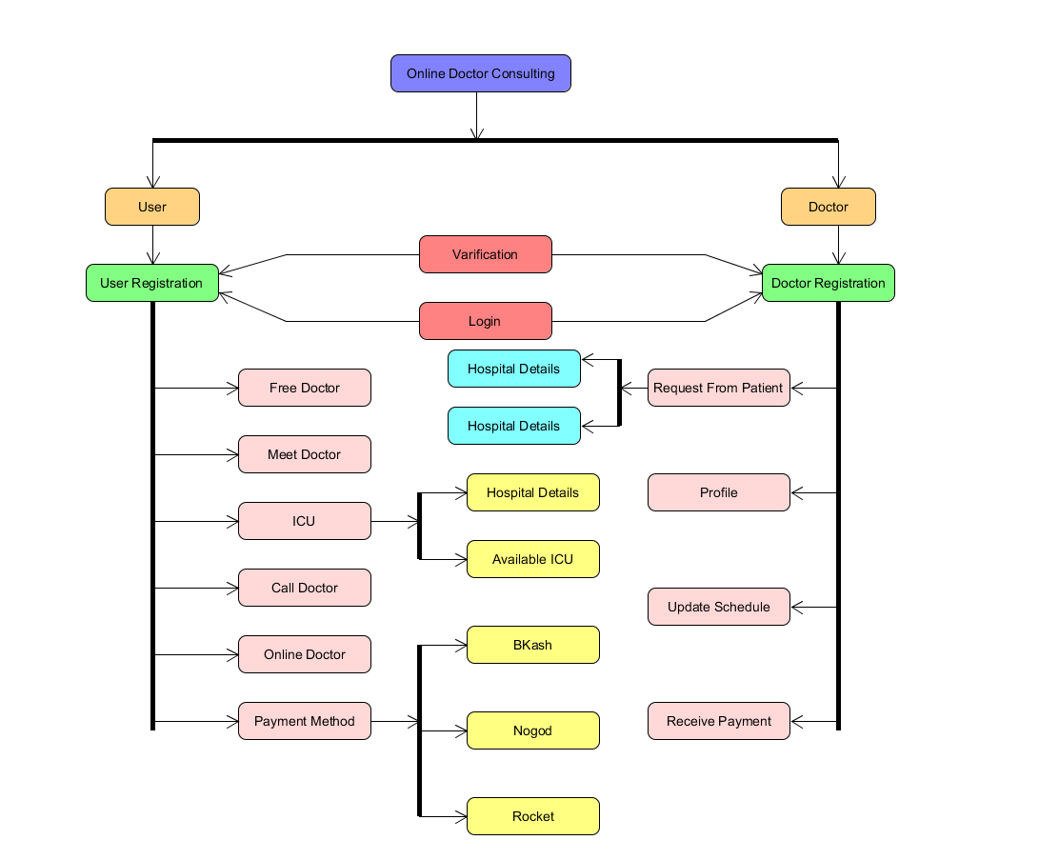

**References**

[1] Roger Pressman. 2009. Software Engineering: A Practitioner’s Approach (7th. ed.). McGraw-Hill, Inc., USA.

[2] Wong, K. (2015).Software Processes and Agile Practices. University of Alberta.

[3] Pressman, R.S (2005). Software Engineering: A Practitioner’s Approach.

[4] Lab Manual